Post Lab 6

Frederick Rice u1252010

<https://github.com/u1252010/ECE-6780-u1252010>

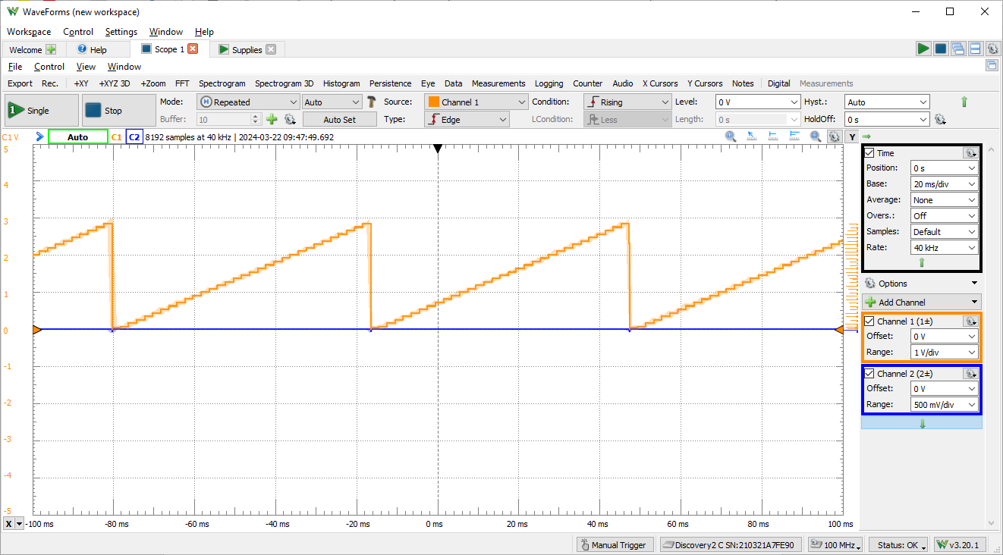

1. 250 kHz / 200 = 1.25 kHz
2. (3 – 0) / 4096 = 732.4 $μV$  
   1.75 V / 732.4 $μV$ $≈$ 2389